# Archer Exam Management

Archer Exam Management solution enables organizations to more effectively prepare for, document and manage the processes for conducting an examination by providing a centralized platform to efficiently manage the scoping, data collection, collaboration and post analysis phase of an exam. Using this solution, organizations are better able to track the phases of the exam, assign and track information requests, log hours worked on each phase, and maintain visibility into related loss events. In addition, robust reporting tools and graphical dashboards provide professional looking reports to inform executives of exam status, findings and remediation activities.

On this page

* Release notes
* Overview of Archer Exam Management
  + Key features and benefits
  + Prerequisites (ODA and system requirements)
  + Compatible use cases and applications
    - Related applications
* Archer Exam Management components
  + Architecture diagram
  + Swim lane diagram
  + Applications
  + Personas and access roles
  + Permissions chart
* Installing Archer Exam Management
  + Installation overview
    - Task 1: Prepare for the installation
    - Task 2: Install the package
    - Task 3: Set up data feeds
    - Task 4: Test the installation
  + Installing the package
    - Task 1: Back up your database
    - Task 2: Import the package
    - Task 3: Map objects in the package
    - Task 4: Install the package
    - Task 5: Review the package installation log
    - Step 6: Activate advanced workflow
  + Setting up data feeds
    - Task 1: Configure data feed
    - Task 2: Schedule a data feed
* Using Archer Exam Management
  + Task 1: Create an exam users - Exam manager procedure
  + Task 2: Scoping & impact analysis phase
  + Task 3: Data collection requests
  + Task 4: Data collection users - information owner procedure
  + Task 5: Data collection review phase
  + Task 6: Wrap-up phase users - Exam manager procedure
  + Task 7: Exam completion phase users - Exam manager, exam owner procedure
  + Task 8: Log exam hours
  + Task 9: Auto-generate exam users - Exam manager, exam owner procedure
* Upgrading Archer Exam Management
* Certification environment

## Release notes

| Release Version | Published Date | Notes |
| --- | --- | --- |
| Archer 6.2 | November 2017 | Initial Release |
| Archer 6.9 | April 2021 | * Require less ODAs for implementation. Excluded Exam Evidence Document Repository ODA from the package. * Improved the user experience with updated dashboards. Added new iViews to Exam Manager/Owner and Information Owner Dashboard * Added fields to track Exam Frequency, regulatory information. Added Report Objects in the Exam Management app. * Added Report Objects to summarize Data Collection and Review and Exam Hours in Exam Management application. * Created a data feed to auto-generate next exam. |

## Overview of Archer Exam Management

### Key features and benefits

Interacting with regulatory bodies typically involves a large time investment, especially for medium and large organizations in business sectors such as financial services, telecommunications, healthcare and other highly-regulated industries. In addition, providing these regulators with hard copies of sensitive information creates potential risk, as this information could be lost or stolen. Establishing a consistent, centralized process for managing requests for information from regulators increases the consistency of responses, allows for a reduction in duplicated information, minimizes the exposure of sensitive information and reduces the time required to aggregate and disseminate the data.

With Archer Exam Management, you will be able to:

* Manage the process of submitting and responding to regulatory request through an access- controlled environment to prevent the exposure of sensitive data.
* Eliminates the need for producing hard copies of sensitive data, thereby greatly minimizing the risk of loss or theft of confidential company information.
* Identify outstanding information requests and assign information owners to research and submit evidence.
* Attach documentation from regulators and supporting evidence from your organization
* Store answers to previous regulatory questions to enable rapid response to similar questions in the future.
* Report on the status of all regulatory inquiries across your organization.
* Link examinations to specific divisions, business units, and products and services.

Benefits include:

* Simplify collaboration of the data collection process of evidence for regulatory examinations.
* Increase the likelihood examiner receives accurate and complete information.
* Centralized document repository management including version control and historical archival.
* Quickly identify and communicate with Information Owners.
* Reduce penalties or fines from regulatory violations.
* Analyze past examination results and trends to augment the preparation and response to current and future exams.
* Track hours worked on each exam phase to effectively manage assignments and improve the efficiency of future examinations.

### Prerequisites (ODA and system requirements)

| Components | Recommended Software |
| --- | --- |
| Archer | Archer 6.9 and later |
| ODA License | Archer Exam Management requires 2-3 ODA licenses. |
| Pre-Requisite Applications | N/A |

### Compatible use cases and applications

#### Related applications

| Application | Use Case | Primary Purpose(s) of the Relationship |
| --- | --- | --- |
| Business Unit | IT Asset Catalog, Issues Management | Link regulatory examination to Business Unit |
| Company | IT Asset Catalog, Issues Management | Link regulatory examination to Company |
| Division | IT Asset Catalog, Issues Management | Link regulatory examination to Division |
| Contacts | IT Asset Catalog, Business Asset Catalog | Link regulatory examination to Contacts |
| Findings | Issues Management | Document findings resulting from examination |
| Loss Events | Loss Event Management | Detail loss events resulting from regulatory violations |
| Products & Services | Business Asset Catalog, Third Party Risk Management | Link regulatory examination to Products & Services |
| Regulatory Communications | Privacy Program Management | Link Regulatory Communications to examination. |
| PBC Documentation Requests | Financial Controls Monitoring | Document PBC Documentation Request from examination. |

## Archer Exam Management components

### Architecture diagram

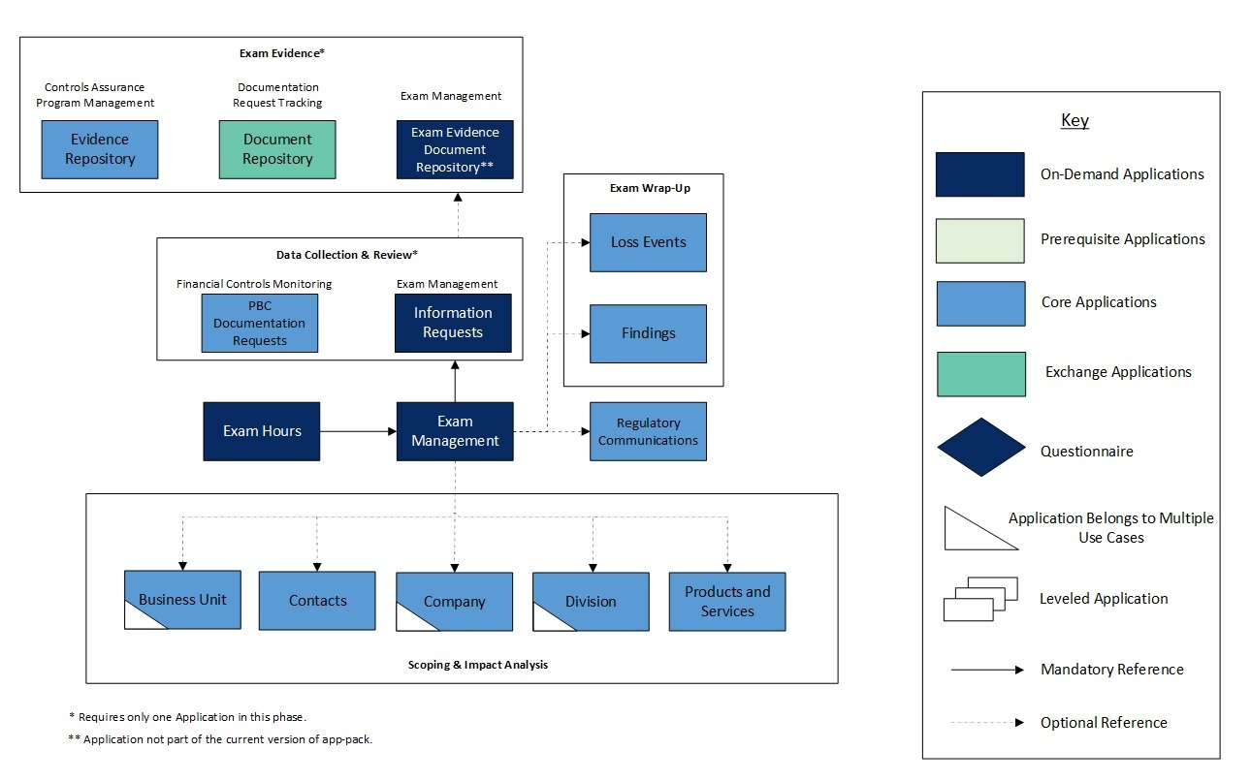

### Swim lane diagram

The Archer Exam Management process begins when the Exam Manager creates a new exam record. The examination is subsequently scoped and linked to a specific company, division, business unit, or product and service. Once the readiness checklist is complete, the exam transitions to the data collection and review phase. Here the Exam Manager can log hours spent on exam tasks and request exam evidence from Information Owners. Once all information is gathered and approved the wrap-up phase will begin. In this phase the Exam Manager receives findings and any loss events (sanctions, penalties, fees, and fines) from the Regulatory Agency. The examination is then sent to the Exam Owner who is responsible for final negotiation with the Regulators and closing the examination.

The following diagram shows the general workflow of the application.

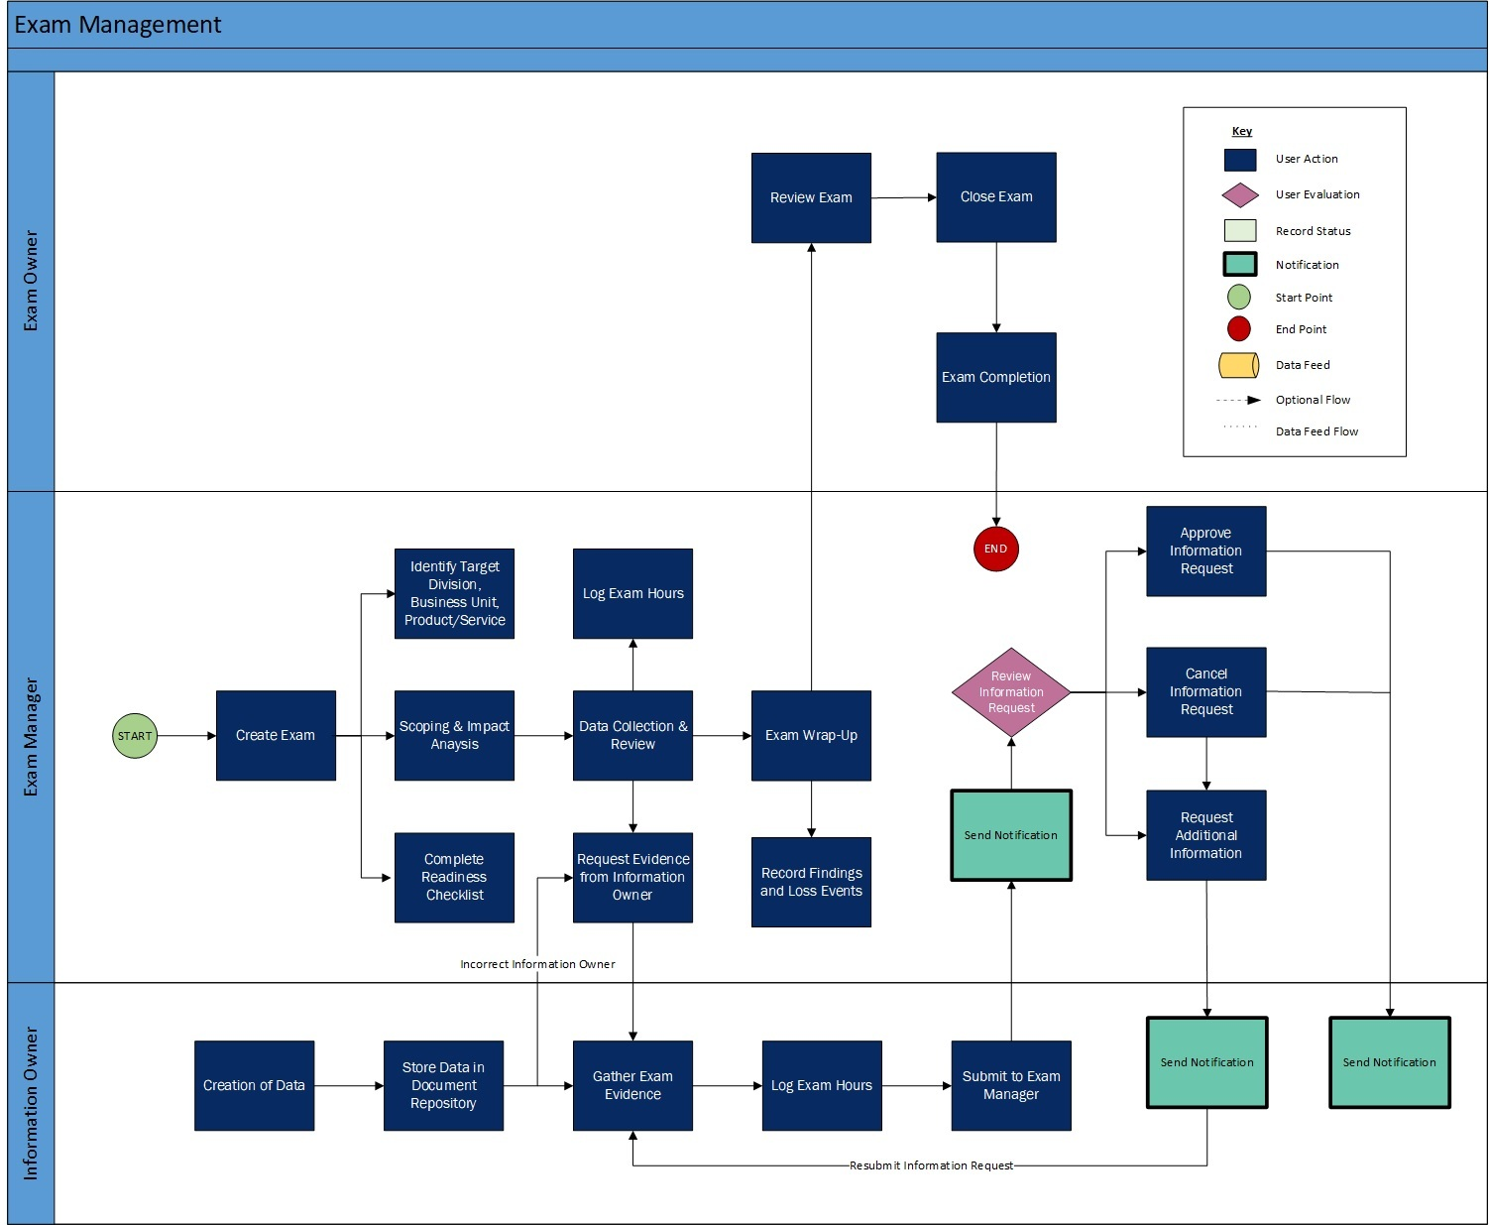

### Applications

| Application | Description |
| --- | --- |
| Exam Management | The Examination Management application establishes a framework for this business process, allowing you to manage multiple informational requests from a secure, centralized location. The application provides an easy way for regulators to submit specific questions to your organization, and it gives you flexible assignment options for addressing individual questions. When responses require supporting evidence, the necessary documentation and files can be uploaded to the application and then viewed by exam managers and owners in a secure environment. By transmitting data through a secure and access-controlled environment, you can eliminate the need for producing hard copies of sensitive data, thereby greatly minimizing the risk of loss or theft of confidential company information. |
| Information Requests | The Information Requests application automates the data collection process of evidence for regulatory examinations. It allows the exam manager to submit a data gathering request to information owners, track the status of the information request, dictate expected delivery times, request more information or  communicate desired revisions to the submitted data. The application also sends notifications to the information owner notifying them that a request has been  made and updates the exam manager when submissions have been completed. The exam manager can also quickly determine if the request is past due and if approved evidence has been submitted to regulators. |
| Exam Hours | The Exam Hours application is used to track the time worked during each phase of the regulatory examination. Exam Hours allows the exam owner, exam manager, and information owners to select the exam, the phase of the examination for which they are performing work, how many hours were spent on the task, when the work began and ended,  and any notes they'd like to add. Hours are tracked by the exam manager and used to evaluate how much time is being spent on each phase of the examination and which information owners are performing the most work. |

### Personas and access roles

| Function | Description |
| --- | --- |
| Exam Manager | Responsible for oversight and management of the internal business process for the exam. The exam manager acts as the formal liaison between the regulator and the rest of the organization once the exam commences. Tasks include capturing and categorizing data requests and providing real-time updates to regulators and key internal stakeholders. |
| Exam Owner | Acts as the business manager for the target of the exam. The exam owner is accountable for the results of the regulatory examination. They are interested in reviewing the exam status and findings, managing any needed escalations, and implementing effective remediation plans. |
| Information Owner | Owns the information that the regulator would like to review. They are responsible for the timely collection and communication of data related to the exam. The exam is not their full-time job. Therefore, they would like to complete the data collection as quickly as possible and return to value added activities. |

### Permissions chart

| Application | Exam Manager | Exam Owner | Information Owner |
| --- | --- | --- | --- |
| Exam Management | CRU* | CRUD | R* |
| Information Requests | CRU* | CRUD | RU* |
| Exam Hours | CRU* | CRUD | CRU* |

C = Create, R = Read, U = Update, D = Delete

*Indicates Record Permissions

## Installing Archer Exam Management

### Installation overview

Complete the following tasks to install the application.

#### Task 1: Prepare for the installation

1. Ensure that your Archer system meets the following requirements:
   * Archer Platform version 6.9
2. Download the ODA install package from the Archer Exchange on:

<https://community.rsa.com/t5/archer-exchange/ct-p/archer-exchange>

1. Obtain the Data Dictionary for the ODA by contacting your Archer Account Representative. The Data Dictionary contains the configuration information for the ODA.
2. Read and understand the "Packaging Data" section of Archer Help.

#### Task 2: Install the package

Installing a package requires that you import the package file, map the objects in the package to objects in the target instance, and then install the package. See Installing the Application Package for complete information.

#### Task 3: Set up data feeds

You must import and schedule each use case data feed that you want to use. See Setting Up Data Feeds for complete information.

#### Task 4: Test the installation

Test the application according to your company standards and procedures, to ensure that the use case works with your existing processes.

### Installing the package

#### Task 1: Back up your database

There is no Undo function for a package installation. Packaging is a powerful feature that can make significant changes to an instance. Archer strongly recommends backing up the instance database before installing a package. This process enables a full restoration if necessary.

An alternate method for undoing a package installation is to create a package of the affected objects in the target instance before installing the new package. This package provides a snapshot of the instance before the new package is installed, which can be used to help undo the changes made by the package installation. New objects created by the package installation must be manually deleted.

#### Task 2: Import the package

1. Go to the Install Packages page.
   1. From the menu bar, click Admin menu.
   2. Under Application Builder, click Install Packages.
2. In the Available Packages section, click Import.
3. Click Add New, then locate and select the package file that you want to import.
4. Click OK.

The package file is displayed in the Available Packages section and is ready for installation.

#### Task 3: Map objects in the package

**Important:** This step is required only if you are upgrading to a later version of [ODA name].

1. From the menu bar, click Admin menu > Application Builder > Install Packages.
2. In the Available Packages section, locate the package you want to map.
3. In the Actions column, click Map package for that package.

* The analyzer examines the information in the package. The analyzer automatically matches the system IDs of the objects in the package with the objects in the target instance and identifies objects from the package that are successfully mapped to objects in the target instance, objects that are new or exist but are not mapped, and objects that do not exist (the object is in the target but not in the source).
* When the analyzer is complete, the Advanced Package Mapping page lists the objects in the package file and corresponding objects in the target instance.

1. On the Advanced Mapping page, click to open each category and review the icons next to each object to determine which objects you must map manually.

The following table describes the icons.

| Icon | Name | Description |
| --- | --- | --- |
| Awaiting mapping review | Awaiting Mapping Review | Indicates that the system could not automatically match the object or one of its children to a corresponding object in the target instance.  Objects marked with this icon must be mapped manually.  New objects should not be mapped. Select Do Not Map from the drop-down menu to clear this icon for an individual object, or click Do Not Map to clear the icon for all unmapped objects. |
| Mapping completed | Mapping Completed | Indicates that the object and all children are mapped to objects in the target instance, or that they have been marked as Do Not Map. Nothing more needs to be done with these objects in Advanced Package Mapping. |

* **Note:** You can run the mapping process without mapping all objects. The Awaiting mapping review icon is for informational purposes only.

1. For objects awaiting mapping review, do one of the following:
   * To map each object individually, use the drop-down menu in the Target column to select the object in the target instance to which you want to map the source object. To leave an object unmapped, select Do Not Map in the Target column.
   * To automatically map all objects in a category that have different system IDs but the same object name as an object in the target instance, click Auto Map. Select whether to ignore case and spaces when matching object names. Click OK.
   * To mark all unmapped objects as Do Not Map, click Do Not Map.
2. (Optional) Click Filter to enable filter fields that you can use to find specific objects in each mapping category. To undo your mapping selections, click Undo, then select whether to undo all mappings in the category or only the mappings on a single page. If you choose to undo all mappings, you will be returned to the categories list.
3. (Optional) To save your mapping selections and return to the categories list without committing changes to the target instance, click RSA.
4. After you review and map all objects, click Execute.
5. Select I understand the implications of performing this operation. Click OK.

* When the mapping is complete, the Import and Install Packages page displays.
* **Important:** Advanced Package Mapping modifies the system IDs in the target instance. You must update any Data Feeds and Web Service APIs that use these objects with the new system IDs.

#### Task 4: Install the package

All objects from the source instance are installed in the target instance unless the object cannot be found or is flagged to not be installed in the target instance. A list of conditions that may cause objects not to be installed is provided in the Log Messages section. A log entry is displayed in the Package Installation Log section.

1. Go to the Install Packages page.
   1. From the menu bar, click Admin menu.
   2. Under Application Builder, click Install Packages.
2. In the Available Packages section, do the following:
   1. Locate the package file you want to install.
   2. In the Actions column, click .
3. In the Selected Components section, select the components of the package that you want to install.

* To select all components, select the top-level checkbox.
* To install only specific global reports in an already installed application, select the checkbox associated with each report that you want to install.

**Note:** Items in the package that do not match an existing item in the target instance are selected by default.

1. Click Lookup.
2. For each component section, do the following:

**Note:** To move onto another component section, click Continue or select a component section in the Jump To drop-down menu.

1. In the Install Method drop-down menu, select an install method for each selected component.

* **Note:** If you have any existing components that you do not want to modify, select Create New Only. You may have to modify those components after installing the package to use the changes made by the package.

1. In the Install Option drop-down menu, select an install option for each selected component.

* **Note:** If you have any custom fields or formatting in a component that you do not want to lose, select Do Not Override Layout. You may have to modify the layout after installing the package to use the changes made by the package.

1. Click OK.
2. To deactivate target fields and data-driven events that are not in the package, in the Post- Install Actions section, select the Deactivate target fields and data-driven events that are not in the package checkbox. To rename the deactivated target fields and data-driven events with a user-defined prefix, select the Apply a prefix to all deactivated objects checkbox, and enter  a prefix. This can help you identify any fields or data-driven events that you may want to review for cleanup post-install.
3. Click Install.
4. Click OK.

#### Task 5: Review the package installation log

1. Go to the Package Installation Log tab of the Install Packages page.
   1. From the menu bar, click Admin menu.
   2. Under Application Builder, click Install Packages.
   3. Click the Package Installation Log tab.
2. Click the package that you want to view.
3. In the Package Installation Log page, in the Object Details section, click View All Warnings.

#### Step 6: Activate advanced workflow

1. Go to the Applications page.
   1. From the menu bar, click Admin menu.
   2. Under Application Builder, click Applications.
2. In the Applications section, select the Information Requests Application.
3. On the Advanced Workflow Tab, click ‘Activate’ in the top right corner of the page.
4. Then click ‘Save Workflow’ in the top left corner of the page.

### Setting up data feeds

One Data Feed is included in the Archer Exam Management app-pack package:

1. Exam Management: Auto-Generate Next Exam: This Data Feed is used to create new Exam records. The report returns data for automatically launching exams on a schedule and is triggered by Auto-Generate Next Exam field value as Yes and Next Exam Date is equal to today’s date in Exam Management application.

#### Task 1: Configure data feed

1. Go to the Manage Data Feeds page.
   1. From the menu bar, click Admin menu.
   2. Under Integration, click Data Feeds.
2. Locate and select the Exam Management: Auto-Generate Next Exam data feed.
3. From the General tab
   1. In the General Information section, set the Status field to Active.
   2. In the Feed Information section, confirm that the Target field is set to Exam Management.
4. Click the Transport tab.
   1. Complete the fields in the Transport Configuration section as follows: In the URL field, type: YourServerName/VirtualDirectoryName/ws/search.asmx
   2. In the User Name and Password fields, type the username and password of a Platform user that has access to all of the records on the Platform instance (from which the data feed is coming).
   3. In the Instance field, type the name of the Platform instance from which the data feed is coming (this is the instance name as you enter it on the Login window).
5. Verify the settings on the Source Definition tab. This will be pre-configured.

**Note:** All the Source Fields on the Source Definition tab will get automatically populated when you import the data feed. Repopulating the fields by clicking on “Load Fields” will lead to removal of two pre-populated fields from the list i.e., Auto-Generate Next Exam and Exam Name Calc Field. Follow the steps below to configure the fields in Source Definition tab:

1. Add a new field by clicking on “Add New” and rename as “Auto-Generate Next Exam” and select field type “Static Text” with value “No” in the Text editor (refer screenshots below).
2. Add a new field by clicking on “Add New” and rename as “Exam Name Calc Field” and select field type “Calculated Field” with formula “=CONCATENATE([Exam_Name]," - ",DATEFORMAT([Next_Exam_Date],"MM.dd.yyyy"))” in the Calculation editor (refer screenshots below).

* 
* Auto-Generate Next Exam:
* 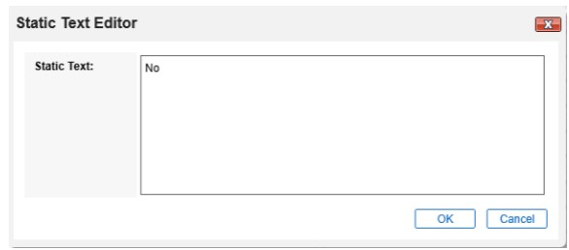
* Exam Name Calc Field:
* 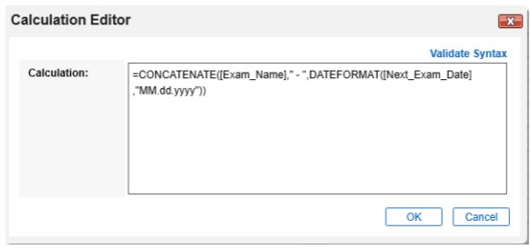

1. Verify the settings and mappings on the Data Map tab.
2. The Key Definition fields should be pre-populated based on the information from the imported Data Feed.
   1. Do not define any key field for Exam Management application.
   2. Define “Tracking ID” as Key fields for all the cross referenced mapped in the Data Feed.
3. Click Save.

#### Task 2: Schedule a data feed

**Important:** A data feed must be active and valid to successfully run.

As you schedule your data feed, the Data Feed Manager validates the information. If any information is invalid, an error message is displayed. You can save the data feed and correct the errors later; but the data feed does not process until you make corrections.

1. Go to the Schedule tab of the data feed that you want to modify.
   1. From the menu bar, click Admin menu.
   2. Under Integration, click Data Feeds.
   3. Select the data feed.
   4. Click the Schedule tab.
2. Go to the Recurrences section and complete frequency, start and stop times, and time zone.
3. (Optional) To override the data feed schedule and immediately run your data feed, in the Run Data Feed Now section, click Start.
4. Click Save.

## Using Archer Exam Management

### Task 1: Create an exam users - Exam manager procedure

1. Go to the Exam Management record.
   1. From the menu bar, click Exam Management.
   2. Under Applications, click Exam Management.
   3. Under More Options, click New Record.
2. Enter all pertinent information related to the exam in the General Information section.
3. Enter an Exam Name, Exam Owner, Exam Type, and Phase.
4. Select the Exam Open Date and Exam Close Date for the Exam.
5. (Optional) In the Exam Purpose field, record any information that describes the reason for the exam.
6. In the Regulatory Information section, select the Agency Location and Primary Regulatory Contacts from their respective fields.
7. Click Save in the Record Toolbar.

### Task 2: Scoping & impact analysis phase

Users: Exam Manager

1. Select the Exam Management record you would like to move to the Scoping & Impact Analysis phase.
2. Click Edit in the top of the record.
3. Select Scoping & Impact Analysis from the Exam Phase dropdown box.
4. Navigate to the Scoping & Impact Analysis tab.
   1. Select the Scope of the examination and the target in the Scoping section.
   2. Choose the Impact Rating from the dropdown box and input an Impact Description in the Impact Analysis section.
   3. Answer the questions in the Readiness Checklist section.
5. Click Save in the Record Toolbar.

### Task 3: Data collection requests

Users: Exam Manager

1. Select the Exam Management record you would like to move to the Data Collection & Review phase.
2. Click Edit in the top of the record.
3. Select Data Collection & Review from the Exam Phase dropdown box.
4. Navigate to the Data Collection & Review. Click on the tab to begin the process.
5. Submit an Information Request by clicking the | Add New | button in the Data Collection & Review section.
6. To link an existing Exam to the Information Request, do the following:
   1. In the Exam Name field, click Ellipsis.
   2. From the Record Lookup window click the check box of the Exam(s) you want to link with the Information Request.
   3. Click OK.
7. Select the Information Owner you wish to send the request to by choosing the down arrow in the Information Owner field and selecting their name.
8. Choose the appropriate Business Unit by clicking Ellipsis next to the field.
9. Select the type of evidence by clicking the down arrow in the Evidence Type field.
10. Select the Information Due Date by clicking the calendar icon and picking a date.
11. Once the record is completed, click the Submit Information Request button in the top left of the screen.

### Task 4: Data collection users - information owner procedure

1. Select the Information Requests record you want to provide response from the Tasks section on your Task landing screen.
2. Click Edit in the top of the record.
3. Enter Information Submission Notes that you would like to send to the reviewing Exam Manager.
4. If you are the incorrect Information Owner click Incorrect Information Owner from Actions dropdown at the top left of the screen to return the record to the Exam Manager.
5. To link an existing document, click | Lookup | in the Exam Evidence Document Repository section and select the document you wish to attach.
6. To attach a new document, click | Add New | in the Exam Evidence Document Repository section.
7. Submit hours worked on data gathering click | Add New | in the Exam Hours section.
8. Once you have completed the aforementioned fields click Submit To Exam Manager from Actions dropdown at the top left of the screen.

### Task 5: Data collection review phase

Users: Exam Manager

1. Select the Information Requests record you want to review from the Tasks section on your Task landing screen.
2. Click Edit in the top of the record.
3. After reviewing the submission, document any notes supporting your decision in the Review Notes field.
4. To Approve the information submission click Approve from Actions dropdown at the top left of the screen.
5. To Cancel the information submission click Cancel from Actions dropdown at the top left of the screen.
6. To request a revision to the information submission, enter the details in the Review Notes section and click Request Revision from Actions dropdown at the top left of the screen.
7. Click Save in the Record Toolbar.

### Task 6: Wrap-up phase users - Exam manager procedure

1. Select the Exam Management record that you would like to move to the Wrap-Up phase.
2. Click Edit in the top of the record.
3. Select Wrap-Up from the Exam Phase dropdown box.
4. Navigate to the Wrap-Up tab. Click on the tab to begin the process.
5. Link existing Findings to the Exam by clicking the | Lookup | icon in the Findings section or add new Findings by clicking the | Add New | button.
6. If any Sanctions result from the Examination, choose the down arrow in the Sanctions field and select ‘Yes’. If you choose Yes in the Findings field, you will be prompted to enter a description of the sanctions resulting from the examination.
7. Choose any Violations found during the examination by clicking Ellipsis next to the field name.
   1. Enter any additional details in the Violations Details field.
8. If there are Client Reimbursements resulting from the examination enter the dollar amount in the Client Reimbursements field.
   1. Enter any additional details in the Reimbursement Details field.
9. Click Save in the Record Toolbar.

### Task 7: Exam completion phase users - Exam manager, exam owner procedure

1. Select the Exam Management record that you would like to move to the Exam Completion phase.
2. Click Edit in the top of the record.
3. Select Exam Completion from the Exam Phase dropdown box.
4. Navigate to the Exam Completion tab. Click on the tab to begin the process.
5. Enter any Fine Avoidance, Vendor Costs, Payout Date, Issue Synopsis, and Executive Summary resulting from the examination in the Post Exam Information section.
6. When Exam Manager is ready to submit the Exam for review, select ‘Submitted’ in the dropdown box next to the Post Exam Submission Status field.
   1. Select the Post Exam Submit Date by clicking the calendar icon next to the field and selecting the date you are submitting the exam for review.
7. The Exam Owner will be prompted with a notification that the examination is ready for their review.
8. The Exam Owner can then select the desired status and date in the Post Exam Review Status and Post Exam Review date fields.

### Task 8: Log exam hours

Users: Exam Manager, Exam Owner, Information Owner

1. Go to the Exam Hours record.
   1. From the menu bar, click Exam Hours.
   2. Under Applications, click Exam Hours.
   3. Under More Options, click New Record.
2. Select the Exam Name you want to link to the hours worked by clicking Ellipsis next to the field name.
3. Choose the Phase when the hours were worked by pressing the down arrow next to the field and choosing the appropriate phase.
4. Enter the number of hours worked in the Hours Worked field.
5. Select a Start Date and End Date when the hours were worked by clicking the calendar icon next to the respective fields.
6. Enter any supporting information about the hours worked in the Notes field.
7. Click Save in the Record Toolbar.

### Task 9: Auto-generate exam users - Exam manager, exam owner procedure

1. Select the Exam Management record that you would like to auto-generate next Exam.
2. Click Edit in the top of the record.
3. Select Exam Frequency for the request by clicking the down arrow next to the field and making your selection.
4. Select value Yes in the Auto-Generate Next Exam field by clicking the down arrow next to the field and making your selection.
5. Click Save in the Record Toolbar.

**Note:** Next Exam Date is a calculated field based on the Exam Open Date and Exam Frequency. The criteria to trigger the Data Feed to generate a new exam is: a) Auto-Generate Next Exam = Yes and b) Next Exam Date = Current Date.

## Upgrading Archer Exam Management

For the Archer Exam Management 6.9 release, the app-pack has been updated to align with previous release changes. If you are upgrading from Exam Management version 6.3 to Exam Management version 6.9, be aware of the following changes.

Exam Evidence Document Repository

Exam Evidence Document Repository application was deprecated and excluded from the package. Archer strongly recommends doing one of the following prior to installation:

* If users are using Exam Evidence Document Repository application and wish to utilize the latest package alongside the Exam Evidence Document Repository ODA, then following changes are required during package installation.
  + Ensure to choose Merge Permissions for the Exam Manager, Exam Owner, and
  + Information Owner access roles.
  + Reference to the field Exam Evidence Document Repository has been removed in the reports mentioned below. If you are using the below reports in Information Requests application in your Archer instance, ensure to not install them during package installation.
    - Information Requests Summary
    - Information Not Sent to Regulators
    - Information Sent to Regulators
    - Approved Information Requests
    - My Approved Information Requests
    - My Cancelled Information Requests
    - My Rejected Information Requests
* If users are NOT using Exam Evidence Document Repository application and wish to utilize the latest package with an application that serves as the central storage and retrieval system for evidence collected and reviewed for exam regulators. Following changes are recommended after package installation.
  + Ignore the warnings related to Exam Evidence Document Repository application in package installation page.
  + Install either one of the below applications in Archer and create a cross reference in Exam Management solution.
    - Document Repository ODA from Documentation Request Tracking Archer Exchange app-pack. For more details, refer the link: [https://community.rsa.com/t5/archer-exchange-documentation/rsa-archer-](https://community.rsa.com/t5/archer-exchange-documentation/rsa-archer-documentation-request-tracking-app-pack/ta-p/563871) [documentation-request-tracking-app-pack/ta-p/563871](https://community.rsa.com/t5/archer-exchange-documentation/rsa-archer-documentation-request-tracking-app-pack/ta-p/563871)
    - Evidence Repository application from Controls Assurance Program Management use case. For more details, refer the link: [https://community.rsa.com/t5/archer-platform-documentation/controls-](https://community.rsa.com/t5/archer-platform-documentation/controls-assurance-program-management/ta-p/555419) [assurance-program-management/ta-p/555419](https://community.rsa.com/t5/archer-platform-documentation/controls-assurance-program-management/ta-p/555419)

Information Requests

Information Requests application is included in the package. Archer strongly recommends doing one of the following prior to installation:

* If users are using Information Requests application and wish to utilize the latest package alongside the Information Requests ODA, then no further changes are required during package installation.
* If users are NOT using Information Requests application and wish to utilize the latest package with application that automates the data collection process of evidence for regulatory examinations. Following changes are recommended.
  + Install either one of the below applications in Archer.
    - Information Requests application from Archer Exam Management 6.9 app-pack.
    - PBC Documentation Requests application from Financial Controls Monitoring use case. For more details, refer the link: [https://community.rsa.com/t5/archer-blog/archer-financial-controls-](https://community.rsa.com/t5/archer-blog/archer-financial-controls-monitoring/ba-p/567657) [monitoring/ba-p/567657](https://community.rsa.com/t5/archer-blog/archer-financial-controls-monitoring/ba-p/567657)

The following table describes components in the Information Requests application that were changed in the 6.9 release.

|  |  |
| --- | --- |
| Components | Changes Made |
| Layouts | * 001: Default Layout * 002: Information Provision * 003: Information Review   In the above layouts, new section “Workflow and Approvals” has been created and the following fields are placed in the section: “Information Submission Status”, “Information Submission Notes”, “Information Submission Date”, “Review Status”, “Review Notes”, “Review Date”, “Past Due”, “Sent to Regulator”. |
| Layouts | Deleted 004: Resubmission Layout |

Exam Management

The following table describes components in the Exam Management application that were changed in the 6.9 release.

|  |  |
| --- | --- |
| Components | Changes Made |
| Fields | * Added new values list field “Exam Frequency”. * Added new values list field “Auto-Generate Next Exam”. * Added new date field “Next Exam Date”. * Added new date field “Override Next Exam Date”. * Added new cross-reference field “Launch Examination”. * Added new related records field “Originating Exam”. * Added new External Links field “Regulatory Information Link”. * Added new cross-reference field “Regulatory Communications”. * Added new cross-reference field “PBC Documentation Requests”. |
| Report Objects | * Added new report objects (Information Requests by Review Status, Information Request Expiring within 30 days) in data collect & review tab. * Added new report objects (Exam Hours Breakout by Phase, Hours Worked by Investigator per Phase) in exam completion tab. |

## Certification environment

Date tested: April 2021

| Product Name | Version Information | Operating System |
| --- | --- | --- |
| Archer Suite | 6.9 | Virtual Appliance |